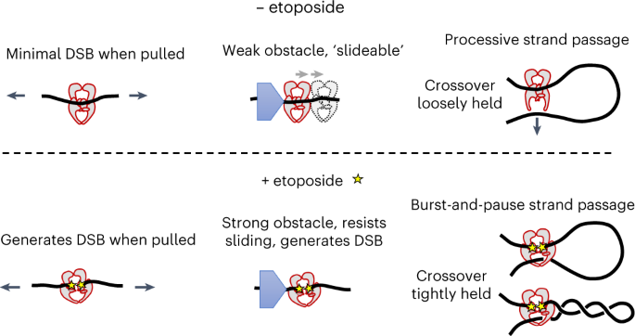
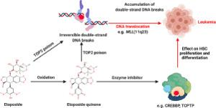
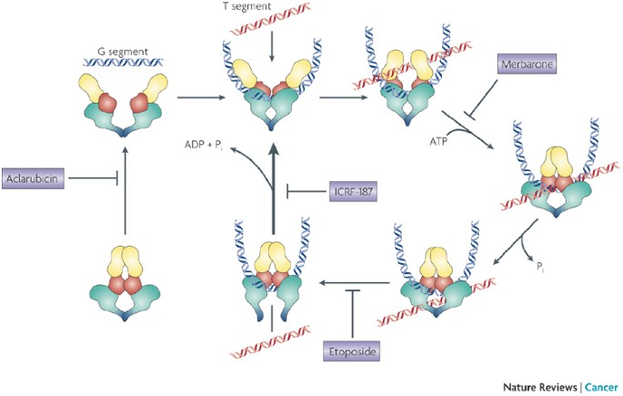
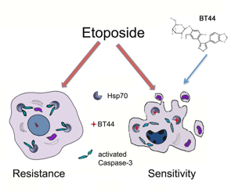
Etoposide is a chemotherapy drug that works by inhibiting the enzyme topoisomerase II, crucial for DNA replication and repair. It poisons the topoisomerase II cleavage complex by stabilizing this intermediate, which prevents the re-ligation (rejoining) of DNA strands after the enzyme cuts them, resulting in accumulation of double-strand DNA breaks (DSBs). These breaks disrupt DNA synthesis and trigger DNA damage responses and apoptosis (programmed cell death) in cancer cells125.

Mechanism of Action Details
- Etoposide forms a ternary complex with DNA and topoisomerase II, stabilizing the cleavage complex and blocking the normal DNA repair step. This leads to persistent protein-associated DNA breaks that are highly toxic to cells16.
- It primarily affects cells in the S and G2 phases of the cell cycle by interfering with DNA replication and mitosis28.
- DNA damage induced by etoposide activates the ATM kinase pathway and downstream effectors such as Chk2, leading to cell cycle arrest and recruitment of DNA repair complexes like MRN (Mre11/Rad50/NBS1) and γH2AX foci1.
- Etoposide also influences replication foci and gene transcription, disrupting chromatin organization even in non-replicating cells, ultimately activating pro-apoptotic factors such as PUMA and caspases1.
- The tumor suppressor p53 plays a key role in etoposide-induced apoptosis, with regulatory pathways involving kinases like NLK which stabilize p53 and promote cell death1.

Clinical Uses
- Treatment of various cancers including testicular cancer, lung cancer, lymphoma, leukemia, neuroblastoma, ovarian cancer, Kaposi’s sarcoma, and glioblastoma multiforme510.
- Frequently used in combination with other chemotherapeutics such as bleomycin for testicular cancer.
- Sometimes part of conditioning regimens prior to bone marrow or stem cell transplantation5.

Administration
- Given either intravenously (slow infusion over 30–60 minutes to avoid hypotension) or orally in capsule or tablet form5.
- Oral absorption varies but is generally about 50% bioavailable2.
- Does not penetrate well into cerebrospinal fluid2.

Side Effects
- Common side effects include bone marrow suppression, nausea, vomiting, hair loss, diarrhea, fever, and risk of allergic reactions and low blood pressure during infusion5.
- DNA damage and secondary malignancies are concerns due to the drug’s mechanism and metabolites3.

Summary
Etoposide is a topoisomerase II poison that induces lethal DNA damage by stabilizing the enzyme-DNA cleavage complex and inhibiting DNA re-ligation, causing accumulation of DNA breaks, cell cycle arrest, and apoptosis. Its activity is phase-specific (S/G2), dependent on DNA damage response pathways including ATM and p53, and widely used against multiple cancers both alone and in combination regimens125.
- https://pmc.ncbi.nlm.nih.gov/articles/PMC4652635/
- https://go.drugbank.com/drugs/DB00773
- https://www.sciencedirect.com/science/article/pii/S1936523321001613
- https://www.ncbi.nlm.nih.gov/books/NBK557864/
- https://en.wikipedia.org/wiki/Etoposide
- https://www.lgcstandards.com/ES/en/Resources/Articles/Pharma-roots-Etoposide
- https://www.mdpi.com/1422-0067/26/2/796
- https://www.sciencedirect.com/topics/pharmacology-toxicology-and-pharmaceutical-science/etoposide
- http://www.bccancer.bc.ca/drug-database-site/Drug%20Index/Etoposide_monograph.pdf
- https://www.cancerresearchuk.org/about-cancer/treatment/drugs/etoposide

